Dropdown for Country

Dropdown for Year

Interactive World Happiness Visualization with options to select from

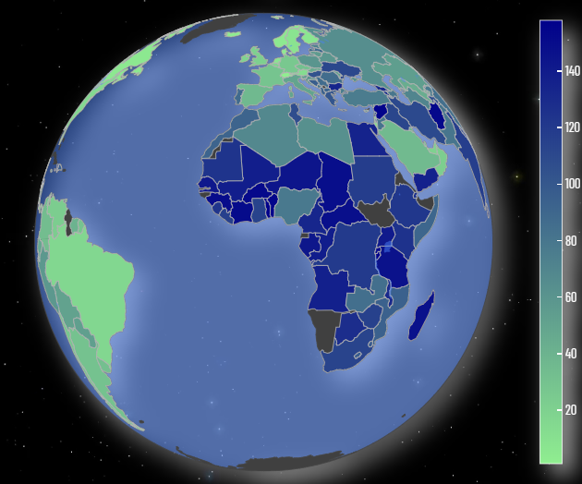

Happiness Score visualized by a Gauge Graph

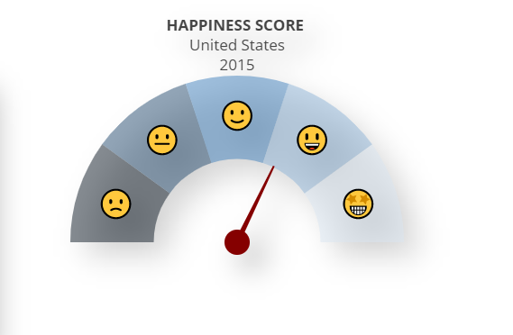

Exploring all the factors that result in the overall happiness in a country

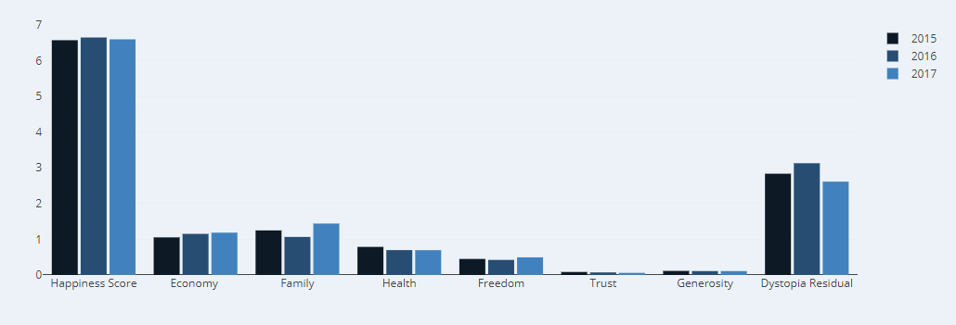

CORRELATION BETWEEN THE VARIABLES OF HAPPINESS

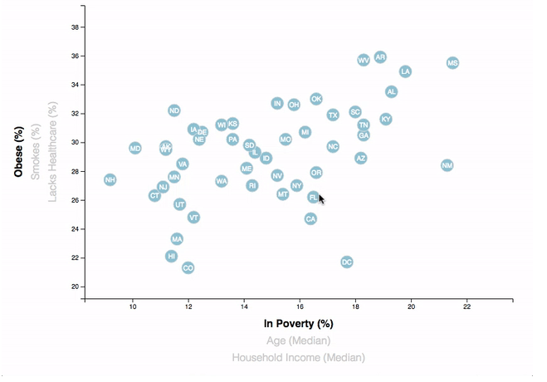

Happiness Data being viewed as the data

|  |  |  |
| --- | --- | --- |
| Factors | Data | Description |
| Happiness Score |  |  |
| Happiness Rank |  |  |
| Economy ( GDP per Capita) |  |  |
| Family |  |  |
| Health |  |  |